GEORGIOS MANIAS

© 2025 Georgios Manias. All rights reserved.

DATABASE DESIGN University Library

REQUIREMENTS ANALYSIS

The university has a library, where librarians have exclusive control over the database.

The only service provided by the library is the LOAN of available books. Each loan is characterized by a) a unique Loan Code, b) a Copy Code, c) Librarian Registration Number, d) Registration Number, e) Loan Date, g) Return Date and h) Loan Status ('Borrowed', 'Returned').

* It should be noted that there is no strict return date as this is a time-consuming academic study. Simply, if a return is too late, an e-mail is sent by librarians as a reminder.
* Each loan always refers to a copy.

Students interested in accessing the books should go to a librarian and create a Profile with their information. Each STUDENT is characterized by a) a unique Registration Number, b) Full Name, c) Date of Birth, d) Department, e) Academic Email.

* Each student can make multiple copy loans. For example, if he borrows a programming book and an information systems security book, he will have made 2 loans.

Students choose the copy they want and go to the librarian's office. In order to be able to get the book, a librarian must register the loan. Each librarian, when registering a loan, for the purpose of tracing responsibility, is registered in a table that relates the loan to him. Each LIBRARIAN is characterized by a) a unique Identity Card, b) Full Name.

* Every librarian can make many loans, and always a borrower must be responsible.
* There is a possibility that a librarian will never borrow if he is in a different position in the library.

Copies of a book can be more than one. A COPY is characterized by a) a unique Copy Code, b) an ISBN, c) a Copy Status (Available, Damaged, Lost) and d) a Shelf Code.

In order for students to be able to quickly find the desired book, they can consult the librarians for its location. The SHELF is characterized by a) a unique Shelf Code, b) a Library, and c) a Corridor where each book is located.

* For an available copy, there must always be a unique Shelf Code that is just that.
* There is a possibility that the shelf position has not yet been caught by a book or has been left empty after the loss of one.

In order for librarians to be able to understand which book students are looking for and to give them the right shelf, they must have various information about this book. The BOOK is characterized by a) a unique ISBN, b) Category Code, c) Title, d) Author, e) Publisher, and g) Year of Publication.

* Copies must always correspond to a book. Of course, multiple copies can correspond to the same book.
* In some case where all copies are lost, the book may be left without a copy.

Finally, many times the student does not have knowledge of what he is looking for, as the professor has given him a topic for work e.g. artificial intelligence. The librarian should be able to give him books about the categories. The CATEGORY is characterized by a) a unique Category Code, b) Category Name, c) Description.

* Many books can fall into the same category. A book should always have a single category.
* There is, of course, the possibility that a category will be left without a book after the loss of them.

## ENTITY-RELATIONSHIP DIAGRAM

## RELATION TABLE

|  |  |  |  |
| --- | --- | --- | --- |
| **ENTITIES** | **CORRELATION** | **MULTIPLICITY** | **COMMENT** |
| STUDENT – LOAN | Borrow | 1:N | Mandatory on the Loan side |
| LENDING – LIBRARIAN | Lent | N:1 | Mandatory on the Loan side |
| LOAN – COPY | Takes place | 1:1 | Mandatory on the Loan side |
| COPY – BOOK | Refers | N:1 | Mandatory on the part of the Copy |
| COPY – SHELF | There is | 1:1 | Mandatory on the part of the Copy |
| BOOK – CATEGORY | Belongs to | N:1 | Mandatory from the Book side |

## RELATIONAL MODEL

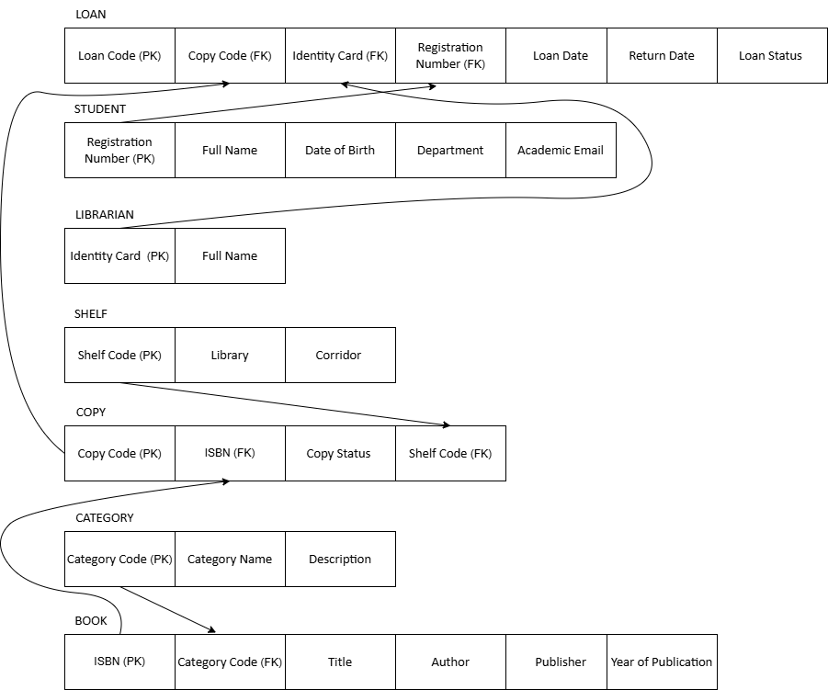

## BASIC APP FUNCTIONS

In this application, all data will be able to be modified by librarians, as they are the administrators of the library and no one else has access. For the needs of librarians to manage loans and copies, the application must be able to retrieve the following information:

* All loans that are in progress. The application must retrieve the following information: Librarian in Charge, Loan Code, Registration Number, Loan Date, Student Name, Academic Email, Book Title, ISBN
* How many copies each book has available so that they can identify their orders. The application must retrieve the following information: Book Title, ISBN, Number of Copies.
* All loans that are in progress, for a specific librarian. The application must retrieve the following information: Loan Code, Registry Number, Loan Date, Student's Name, Academic Email, Book Title, ISBN
* All loans that are in progress, for which a specific librarian is responsible and the borrowing time has exceeded two months, in order to contact the student. The application must retrieve the following information: Loan Code, Registration Number, Loan Date, Student Name, Academic Email, Book Title, ISBN, Loan Time
* Which book copies take longer to return: Title, ISBN, Average Time

## Implementation of Queries Referenced in Requirements Analysis

**Question 1:**All loans that are in progress. The application must retrieve the following information: Librarian in Charge, Loan Code, Registry Number, Loan Date, Student Name, Academic Email, Book Title, ISBN

SELECT

l.full_name AS Responsible_Librarian,

loan.loan_id AS Loan_Code,

s.student_id AS Registration_Number,

loan.loan_date AS Loan_Date,

s.full_name AS Name_Surname_Student,

s.academic_email AS Academic_Email,

b.title AS Book_Title,

b.isbn AS ISBN

FROM Loan loan

JOIN Student s ON loan.student_id = s.student_id

JOIN Copy c ON loan.copy_id = c.copy_id

JOIN Book b ON c.isbn = b.isbn

JOIN Librarian l ON loan.id_card_number = l.id_card_number

WHERE loan.loan_status = 'Borrowed';

**Question 2:**How many copies each book has available so that they can identify their orders. The application must retrieve the following information: Book Title, ISBN, Number of Copies.

SELECT

b.title AS Book_Title,

b.isbn AS ISBN,

COUNT(*) AS Number_of_Available_Copies

FROM Copy c

JOIN Book b ON c.isbn = b.isbn

WHERE c.copy_status = 'Available'

GROUP BY b.title, b.isbn;

**Question 3:**All loans that are in progress, for a specific librarian. The application must retrieve the following information: Loan Code, Registry Number, Loan Date, Student's Name, Academic Email, Book Title, ISBN ('VH654321', 'Dimitris Kefalas')

SELECT

loan.loan_id AS Loan_Code,

s.student_id AS Registration_Number,

loan.loan_date AS Loan_Date,

s.full_name AS Name_Surname_Student,

s.academic_email AS Academic_Email,

b.title AS Book_Title,

b.isbn AS ISBN

FROM Loan loan

JOIN Student s ON loan.student_id = s.student_id

JOIN Copy c ON loan.copy_id = c.copy_id

JOIN Book b ON c.isbn = b.isbn

WHERE loan.loan_status = 'Borrowed'

AND loan.id_card_number = ' VH654321';

**Question 4:**

All loans that are in progress, for which a specific librarian is responsible and the borrowing time has exceeded two months, in order to contact the student. The application must retrieve the following information: Loan Code, Registration Number, Loan Date, Student Name, Academic Email, Book Title, ISBN, Loan Time

('AZ123456', 'Sotiria Papadaki')

SELECT

loan.loan_id AS Loan_Code,

s.student_id AS Registration_Number,

loan.loan_date AS Loan_Date,

s.full_name AS Name_Surname_Student,

s.academic_email AS Academic_Email,

b.title AS Book_Title,

b.isbn AS ISBN,

DATEDIFF(CURDATE(), loan.loan_date) AS Borrow_Time_Days

FROM Loan loan

JOIN Student s ON loan.student_id = s.student_id

JOIN Copy c ON loan.copy_id = c.copy_id

JOIN Book b ON c.isbn = b.isbn

WHERE loan.loan_status = 'Borrowed'

AND loan.id_card_number = 'AZ123456'

AND DATEDIFF(CURDATE(), loan.loan_date) > 60;

**Question 5:**

Which book copies take longer to return: Title, ISBN, Average Time

SELECT

b.title AS Book_Title,

b.isbn AS ISBN,

ROUND(AVG(DATEDIFF(loan.return_date, loan.loan_date)), 1) AS Average_Borrowing_Time_Days

FROM Loan loan

JOIN Copy c ON loan.copy_id = c.copy_id

JOIN Book b ON c.isbn = b.isbn

WHERE loan.loan_status = 'Returned'

GROUP BY b.title, b.isbn

ORDER BY Average_Borrowing_Time_Days DESC;